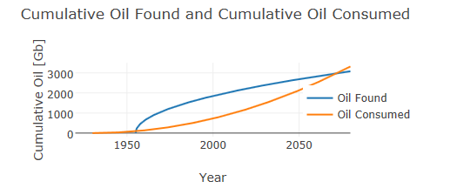

http://www.wired.com/2015/02/infinite-amount-oil-enough/